**Project Design Phase-II**

**Data Flow Diagram & User Stories**

|  |  |
| --- | --- |
| Date | 02 August 2025 |
| Team ID | LTVIP2025TMID36809 |
| Project Name | Traffic Telligence : Advanced Traffic Volume Estimation with Machine Learning |
| Maximum Marks | 4 Marks |

**Data Flow Diagrams:**

A Data Flow Diagram (DFD) is a traditional visual representation of the information flows within a system. A neat and clear DFD can depict the right amount of the system requirement graphically. It shows how data enters and leaves the system, what changes the information, and where data is stored.



**Example:** [**(Simplified)**](https://developer.ibm.com/patterns/visualize-unstructured-text/)



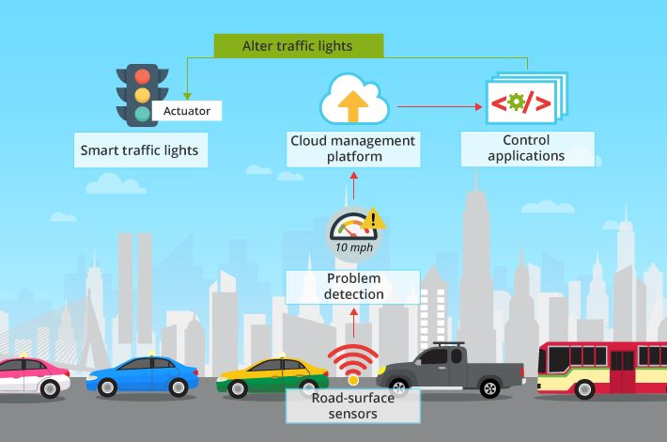

**User Stories**

Use the below template to list all the user stories for the product.

| **User Type** | **Functional Requirement (Epic)** | **User Story Number** | **User Story / Task** | **Acceptance criteria** | **Priority** | **Release** |
| --- | --- | --- | --- | --- | --- | --- |
| Customer (Mobile user) | Registration | USN-1 | As a user, I can register for the application by entering my email, password, and confirming my password. | I can access my account / dashboard | High | Sprint-1 |
| Email | confirmation | USN-2 | As a user, I will receive confirmation email once I have registered for the application | I can receive confirmation email & click confirm | High | Sprint-1 |
| User | Register | USN-3 | As a user, I can register for the application through Facebook | I can register & access the dashboard with Facebook Login | Low | Sprint-2 |
| User | Application | USN-4 | As a user, I can register for the application through Gmail | I can apply & access the data | Medium | Sprint-1 |
| Customer | Login | USN-5 | As a user, I can log into the application by entering email & password | I can enter data and modify by login | High | Sprint-1 |
| Customer | Dashboard | USN-6 | As a user,I can view my details in dashboard | I need to check my details in dashboard | High | Sprint-1 |
| Customer (Web user) | Checking | USN-7 | As a user, I can check my details | I need to check my credentials | Medium | Sprint-2 |
| Customer Care Executive | validating | USN-8 | As a Customer, I need to validate all assigned details | I can validate every assigned data | Low | Sprint-1 |
| Administrator | Verification | USN-9 | As a user ,Verification is mandatory to proceed for future steps | I can verify information | High | Sprint-2 |